Leander Trophy R Class National Championship 2026
12th February to 15th February 2026

The Organising Authority is the Naval Point Club Lyttelton

NOTICE OF RACE

- RULES
  - The regatta will be governed by the rules as defined in The Racing Rules of Sailing.
  - The Yachting New Zealand Safety Regulations Part 1 shall apply.
  - Appendix T, Arbitration, will apply.

- SAILING INSTRUCTIONS
The sailing instructions will be available at registration and on Naval Point Club website on the day before the event.
https://www.sporty.co.nz/navalpoint/major-events/major-events

- C0MMUNICATION
3.1 The online official notice board is located at https://www.navalpoint.co.nz/on-water/noticeboard/.
3.2 [DP] While racing, from the first warning signal until the end of the last race of the day, except in an emergency, a boat shall not make voice or data transmissions and shall not receive voice or data communication that is not available to all boats.

- ELIGIBILITY AND ENTRY
  - The regatta is open to all boats of the R Class Skiff and 12 ft Skiff classes however to be eligible for the Leander Trophy R Class National Championship and Super-Cup Sprint Series trophy all boats must comply with the R Class Skiff class rules and be a current financial member of the Canterbury R-Class Squadron.
  - Eligible boats may enter online at [Link to Naval Point Club website tba]
by Friday 6th February 2026.
  - To be eligible to compete in this event each competitor shall be a financial member of a club recognised by entrant and crew member’s national authority.
Proof of affiliated club membership is to be presented at registration.

- FEES
  - Required fees are as follows:

CLASS | FEE
R | Nil

- ADVERTISING
  - [DP]Boats may be required to display advertising chosen and supplied by the organising authority. If this rule is broken, World Sailing Regulation 20.9.2 applies.

- SCHEDULE
  - Registration:
0800-0930 Thursday 12th February 2026 at Naval Point Club
  - Briefing
0930-1000 Thursday 12th February 2026 at Naval Point Club Lyttelton.

Dates of racing
Date | R Class
February 12 | racing
February 13 | racing
February 14 | racing
February 15 | racing

  - The scheduled time of the warning signal for Race 1 of the championship is 11.00 hrs on Thursday 12th February 2025.
  - The scheduled time of the warning signal for Race 2 of the championship is 14.00 hrs on Thursday 12th February 2025.
  - The scheduled time of the warning signal for the first races on Friday, Saturday and Sunday is 11.00 hrs.
  - Up to four races can be scheduled per day. It is intended that 3 races per day will be held in normal circumstances, however the option to extend this is included. In such cases adequate advanced notice to all competitors shall be provided in accordance with Section 2 of this document.
  - A total of 9 races are scheduled.
  - It is the intention of the organisers to manage racing, including race start times, to maximise the number of races sailed in 12 to 18 knot wind strengths.
  - A separate Super-Cup Sprint Series will be run on Sunday 15th February after National Championship racing is finished for the day. Scoring is on a low points basis, a minimum of 5 races are to be held (all races count), an extra race shall be held in the event of a tie.

- EQUIPMENT INSPECTION
  - Each R Class boat shall produce or verify the existence of a valid measurement certificate.
  - A boat shall comply with RRS 78.1 at all times when racing.

- VENUE
  - Attachment A shows the location of the regatta venue.
  - Attachment B shows the location of the racing areas.

- COURSES
The courses to be sailed will be Windward Leeward; two laps.

- PENALTY SYSTEM
For all boats RRS 44.1 is changed so that the Two-Turns Penalty is replaced by the One-Turn Penalty.

- SCORING
  - The scoring system is as follows: The scoring system awards points according to the formula 400/ (N+3) where N is the official finishing position of a boat.
  - 5 races are required to be completed to constitute a series. No Score will be excluded.

- SUPPORT PERSON VESSELS
  - [DP] Support vessels shall be registered and identified at registration.
  - [DP] All support person vessels shall always have an engine safety cut out switch (kill cord) attached to the driver while the engine is running, unless prior written exemption has been provided by the Organising Authority.

- HAUL-OUT RESTRICTIONS
[DP] Unless otherwise directed by the Organising Authority, all competing boats and equipment shall be launched and retrieved from Naval Point Club Lyttelton.

- RISK STATEMENT
RRS 3 states: ‘The responsibility for a boat’s decision to participate in a race or to continue to race is hers alone.’ By participating in this event each competitor agrees and acknowledges that sailing is a potentially dangerous activity with inherent risks. These risks include strong winds and rough seas, sudden changes in weather, failure of equipment, boat handling errors, poor seamanship by other boats, loss of balance on an unstable platform and fatigue resulting in increased risk of injury. Inherent in the sport of sailing is the risk of permanent, catastrophic injury or death by drowning, trauma, hypothermia, or other causes.

- INSURANCE
Each participating boat shall be insured with valid marine third-party liability insurance with a minimum cover of $1,000,000 per incident or the equivalent.

- PRIZES
The following prizes will be awarded for R-Class Skiffs complying with the class rules:
R Class Leander Trophy for the National Championship
R Class Kent Prier Trophy
R Class Bank of NSW Trophy
R Class Bill Hayman Cup
R Class Leander Trophy Masters Cup
R Class Leander Cup
R Class Doug Harrison Memorial Trophy
R Class Youth Trophy
R Class Ruddiman Trophy
R Class Pinkney Trophy
R Class Innovation Trophy
R Class Lion Trophy

- FURTHER INFORMATION
For further information please contact:

Naval Point Club Lyttelton
admin@navalpoint.co.nz
(03) 328 7029

Submitted 10th October 2025

Attachment A: Location of Naval Point Club

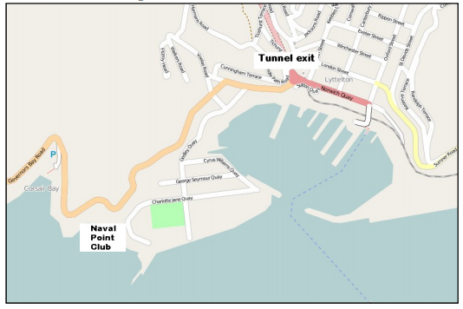

Turn right at Tunnel exit roundabout. Turn first left and follow to
recreation ground. Turn right and follow 300m to NPCL gate.

Attachment B: Racing Area on Lyttelton Harbour

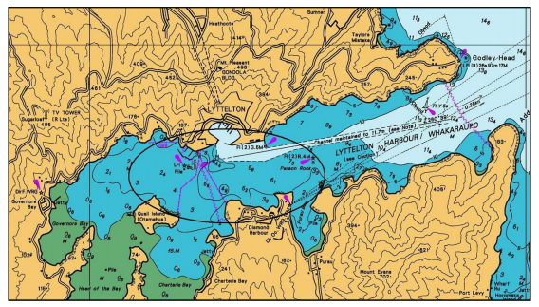

Leander Trophy R Class National championship 2026
12th February to 15th February 2026
Entry Form

Class
Hull Colour
Boat Name
Organising Authority:

Naval Point Club Lyttelton

Street Address
Postal Address
City
Helmsperson | Crew
First Name | First Name
Surname | Surname
Gender | Gender
Yacht Club | Yacht Club
Postal Address | Postal Address
Email | Email
Contact number | Contact number
I agree to be bound by the Racing Rules of Sailing and all other rules that govern this event. I understand that yacht racing has inherent risks and dangers that are beyond the control of the organizing authority. I understand that neither the organising authority and its officers, members, and servants nor other persons assisting with the conduct of the regatta accept any responsibility in respect of any injury or loss to person or property that may be sustained by reason of participation in the regatta or howsoever arising in connection with the regatta.
I agree to the use of my photograph(s) and other relevant information in any event publicity and in the ongoing promotion of New Zealand yachting. I agree to the Organising Authority and Yachting New Zealand holding the above information for the general administration and well-being of the sport, and for them to retain, use and disclose the information to affiliated organisations and any other persons or organisations that Yachting New Zealand believes will further the interests and objectives of Yachting New Zealand. I acknowledge my right to access to and correction of this information. The consent is given in accordance with the Privacy Act 1993.
Helmsperson’s Signature | Crew’s Signature
Date | Date

Enclosures)
Entry Fee | Proof of Club Membership | Certificate of insurance | Measurement Certificate
Nil

